Lecture 2: Introduction to Nucleic Acids and Lipids

Question 1:

Take a look at the two structures below. (1) Can you identify which base pairs are depicted?
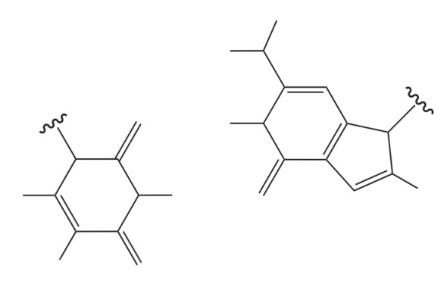
- Can you identify which base pairs are depicted?
- The atom labels are missing in the structure for each atom. Can you label all atoms which correspond to this base pair? If there are hydrogen bonds, please also label them between the base pairs.
- Identify the major and minor grooves of the base pair. Name the interactions along the grooves.
- Is this base pair a standard Watson-Crick pairing?

Answers:

- & b) The left is uracil (pyrimidine) and right is guanine (purine). The aim is just to add all the N, H, and O atoms on each of the bonds. No need for C bonds. Add the H bonds because of the structure but be careful because officially it shows a CH3 bond. Also add the hydrogen bonds between the base pairs.

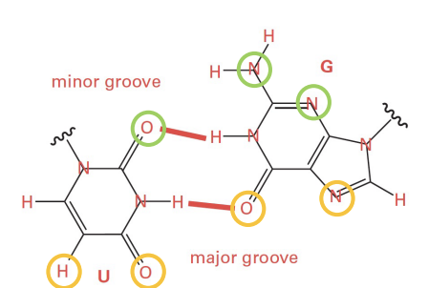
- To identify the grooves, imagine where the glycosidic bond would be and draw a circle. Then the minor groove is on top and major groove is on bottom. The minor groove contains a H-bond acceptor, H-bond donor, and H-bond acceptor. The major groove has a hydrogen atom, H-bond acceptor, H-bond acceptor, H-bond acceptor.

- Typical Watson-Crick pairing C-G or A-T/U. The G-U base pair is not a standard Watson-Crick base pair.

Question 2:

In the image below you can see a cartoon representation of a complex between DNA and the protein p53. This protein is a well-known tumor suppressor protein that regulates the cell cycle and helps prevent cancer by binding to DNA and activating genes that repair damaged DNA. Many DNA interacting proteins contain cationic domains to bind to DNA.
- Explain why these cationic domains are important for DNA-binding proteins (in terms of electrostatic interactions).
- How do these DNA-binding proteins discriminate between specific DNA sequences? Think about the shape and chemical properties (type of interactions) of the protein and how it relates to specificity.
- DNA-binding proteins can be phosphorylated after translation. Why would the cell phosphorylate these proteins and what does it do to DNA binding?
- Mutations in DNA-binding protein can heavily disrupt their function leading to a disease. Why can a mutation in a DNA-binding protein affect the protein-DNA interaction?
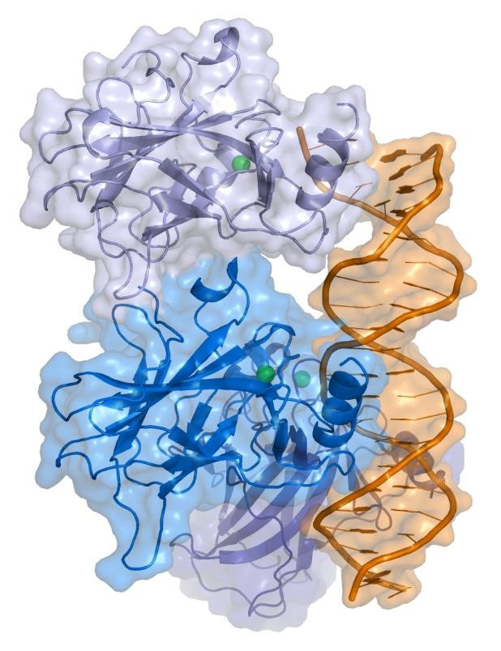

Answers:

- DNA has a negatively charged backbone due to the presence of phosphate groups.
Cationic domain in DNA-interacting proteins carry positive charges, allowing them to
electrostatically bind to DNA. This ensures stable binding and facilitates specific protein-DNA interactions. They are crucial domains for DNA recognition and interaction.

- DNA-binding proteins have unique 3D shapes that fit specific DNA sequences, like a
lock and key. The chemical properties, including hydrogen bonding pattern and hydrophobia interactions allow the protein to recognize base arrangements. Together, shape and chemical specificity enable these proteins to bind to their target DNA sequence. Example is the homeodomain which has a helix-turn-helix motif which nicely fits into the major groove of DNA. An example of chemical properties of this motif is that the positively charged residues on the recognition helix interact with the
negatively charged phosphate backbone of DNA.

- Phosphorylation adds a negatively charged phosphate group to the protein. This alters
the charge distribution and thus reduces or increases affinity for the DNA backbone.
However, phosphorylation can also induce a conformational change that enhances the
fit or chemical interaction with specific DNA sequences. Phosphorylation can modulate
both binding affinity and specificity depending on the protein and its interaction context.

- A mutation in a DNA-binding protein can change its amino acid sequence, potentially
altering its three-dimensional structure or charge distribution. This can affect its ability to recognize or bind to its target DNA sequence. If the mutation affects regions critical for DNA interaction, the protein might lose its binding affinity, bind non-specifically, or bind too tightly. Any of these alterations can disrupt normal cellular processes regulated by the protein-DNA interaction, potentially leading to diseases or dysfunctional cellular behaviours.

Question 3:

A bacterial DNA polymerase replicates DNA at a rate of approximately 1000 base pairs per second. The polymerase holoenzyme is about 110 Å (angstroms) in length. How many times its own length does the polymerase move forward along the axis of the DNA double helix in 5 seconds? Please show the calculation. We can assume that the DNA remains stationary, and we also ignore the rotational movement of the polymerase around the DNA.
Answer:
The polymerase moves at a speed of 1000 bps per second. Thus in 5 seconds it has moves
5000 bps. The distance between two baes is approximately 3.4 angstroms (.). Thus in 5
seconds the enzyme has moved 5000 bps * 3.4 angstroms (.) = 17000. Divided by the
length gives you 17000. /110. = 154.55 times its length.
Question 4:

Non-canonical base-pairing occurs when two nucleotides form hydrogen bonds in a manner distinct from the patterns defined by Watson and Creek. They are particularly common in RNA due to additional flexibility and lack of complementary strands (in most cases). Some examples include Hoogsteen and Wobble pairing.
- In the 6 examples listed below, identify the bases comprising each pair and assign whether they assemble in a canonical (i.e., Watson-Creek) or non-canonical manner?
- What would be the effect of non-canocical base-pairing on the phosphodiester backbone of the poly-nucleotide chain? How would it impact helical assembly? (hint: look at the location of the ribose “R” group)?
- In terms of hydrogen bond count, how do the interactions compare between non-canonical base pairs and the standard A:T/G:C pairs? Which hydrogen bonding network is stronger and why?
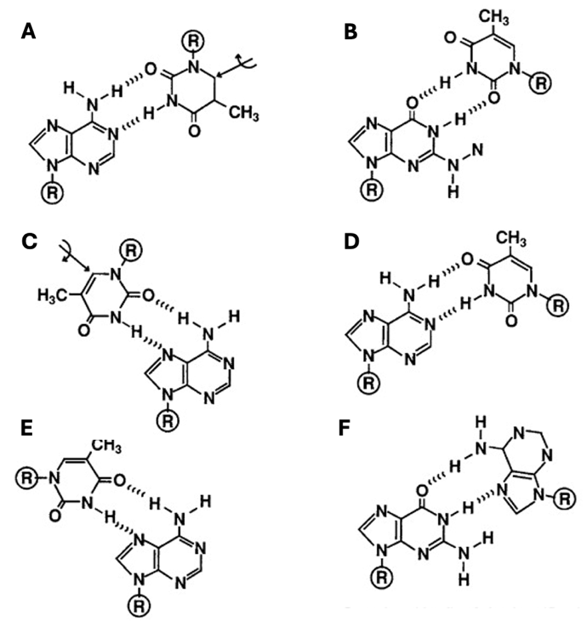
Answers:

- Only 1 canonical pairing (D). The names of each non-canonical assembly are indicated below:
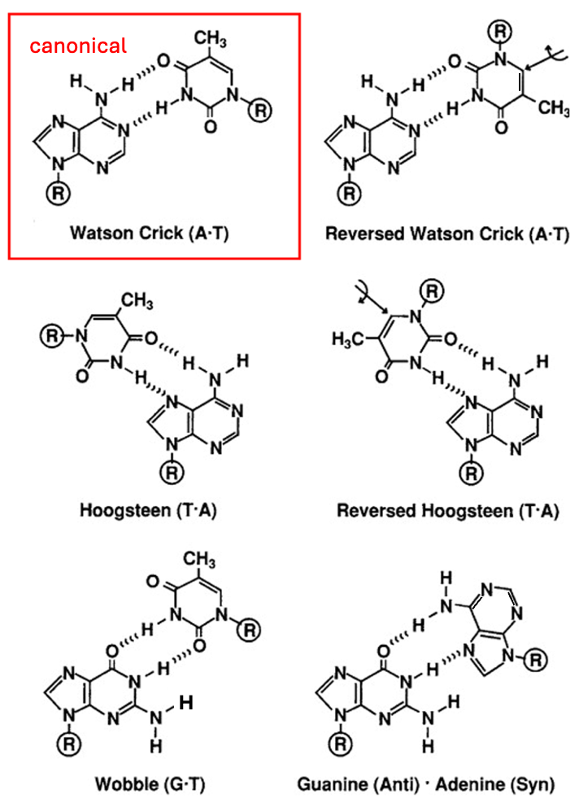

2) Altered hydrogen-bonding pattern would impact the positioning of the phosphodiester backbone ranging from small deformation to complete incompatibility with the double-helical assembly. In fact, some of these base pairs are found in kinks and turns of the RNA chain.

3) If judged by the hydrogen bond count, the strength of most of these interactions are comparable to standard A:T interaction (i.e., 2 hydrogen bonds), and somewhat weaker compared to G:C interactions (3 hydrogen bonds). Of course, this analysis excludes the impact of geometry of each interaction (e.g., angle of approach, distance) and hydrogen bond donor/acceptor groups which also contribute to the binding energy.

Question 5:

Lipid bilayers forming between two water phases have the following important property: they produce bi-dimensional sheets where their edges seal to form liposomes.
a. What lipid-specific properties account for this behaviour?
b. What is the consequence of this property on biological membranes?

Answers:

- Membrane lipids are amphipathic: one end of the molecule is hydrophobic, the other hydrophilic. To minimize the interaction of carbon chains with the aqueous environment, amphipathic molecules align side by side.
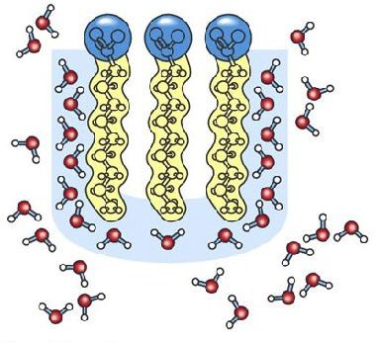

- Allows making up the cell membrane and the membrane of sub-cellular compartments:
  - Interface between the cell and the environment
  - Compartmentalization of the cell

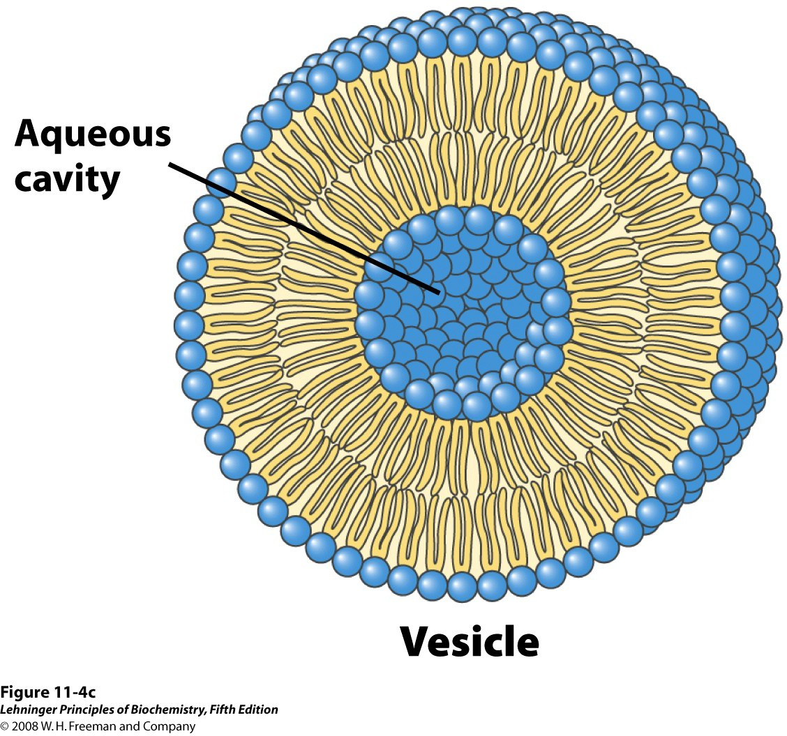
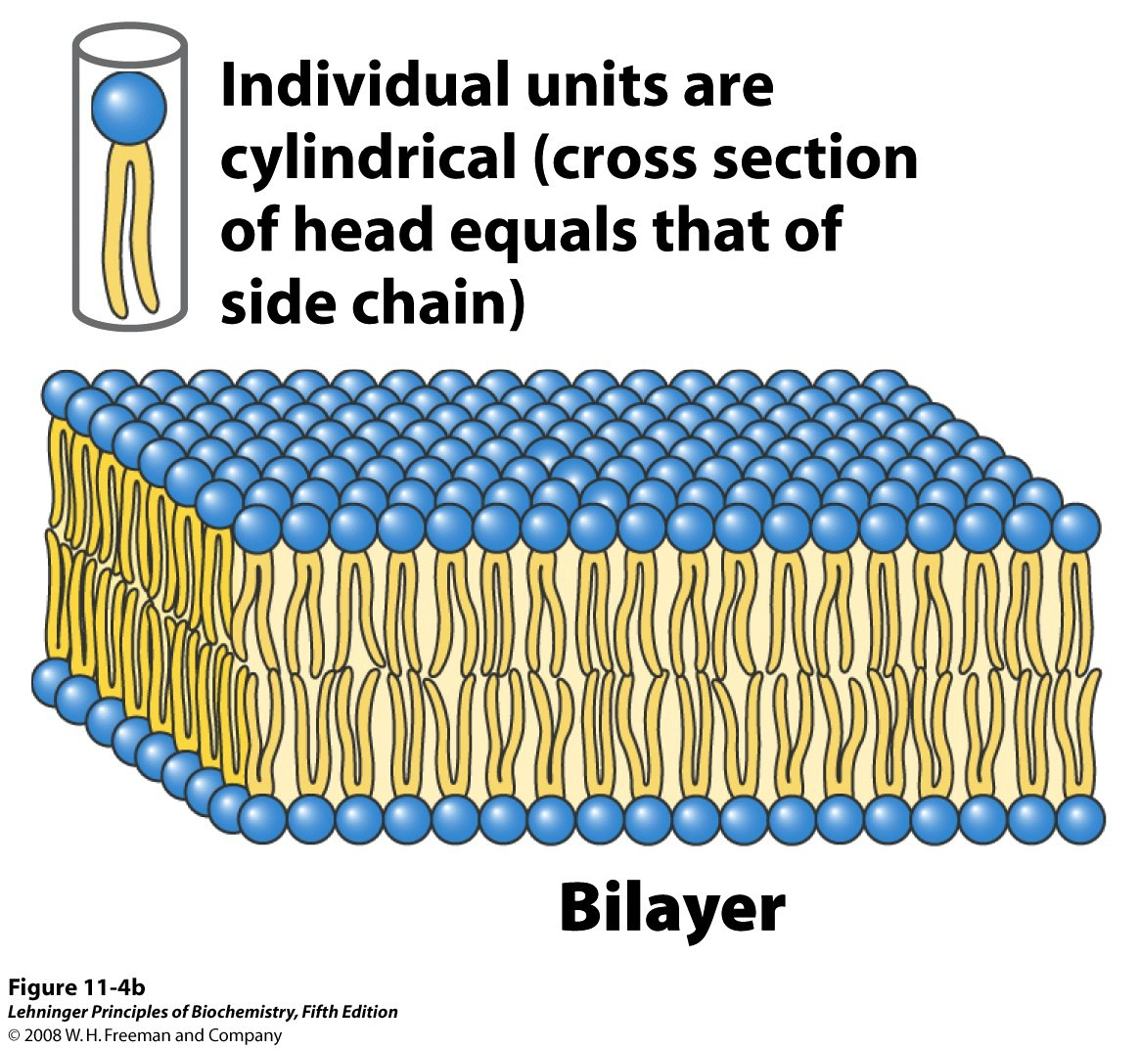

Question 6:
The melting points of a series of 18-carbon fatty acids are: stearic acid, 69.6 C; oleic acid, 13.4 C; linoleic acid, -5 C; and linolenic acid - 11C.
a. What structural aspect of these 18-carbon fatty acids can be correlated with the melting point?
b. List all possible triacylglycerols that can be constructed from glycerol, palmitic acid, and oleic acid. Rank them in order of increasing melting point
c. Branched-chain fatty acids are found in some bacterial membrane lipids. Would their presence increase or decrease the fluidity of the membrane (that is, give them a lower or higher melting point)? Why?

Answers:
- Increasing number of cis double bonds results in:
  - Reduced packing of the hydrocarbon chains
  - Lower melting temperature
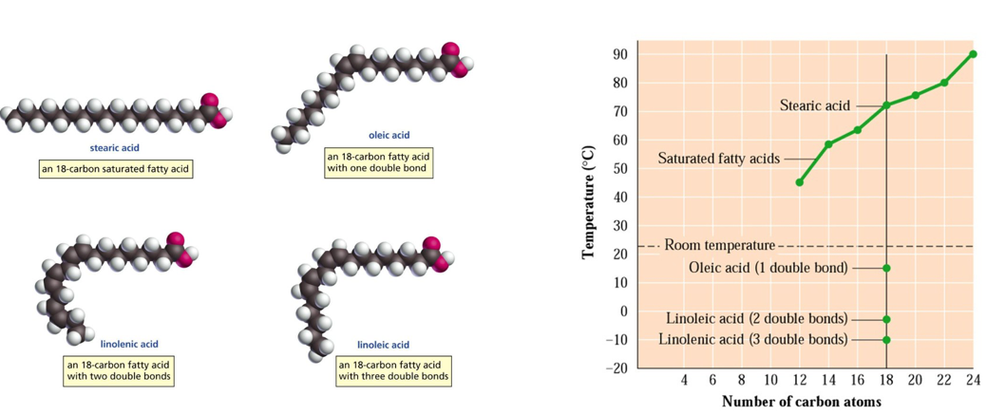

- See all possible combinations below and the ranking based on melting point.
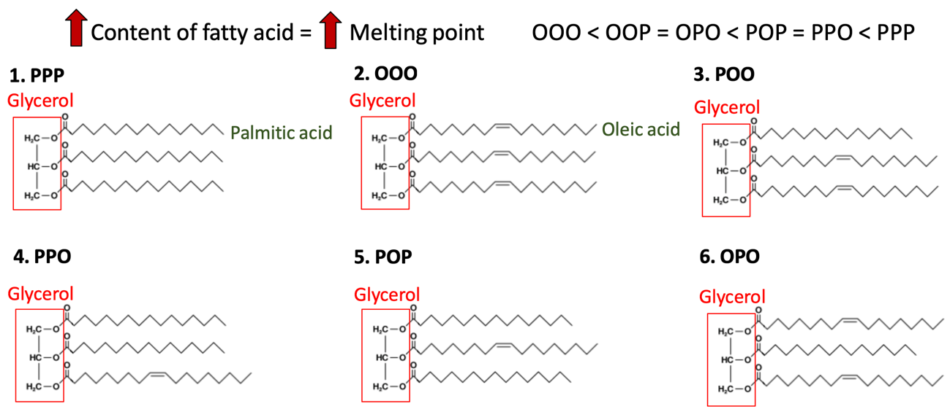

- Some examples are shown below:
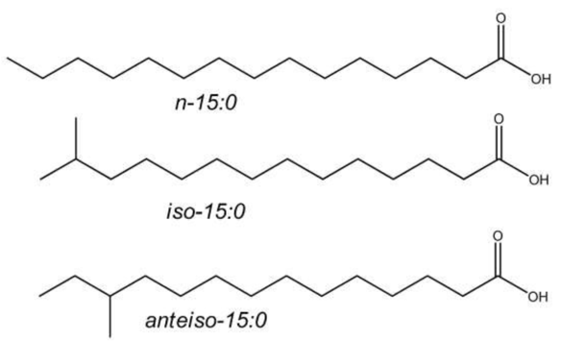
Branching leads to:
  - Increased membrane fluidity
  - Decreased packing
  - Decreased melting point
Its effect is similar to that of bends caused by double bonds
Question 7:
Examine the membrane lipid pictured below and answer the following questions.
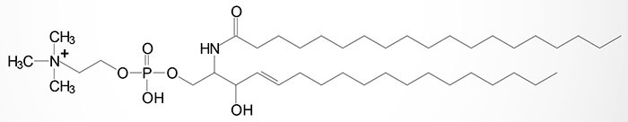
a. Is this lipid classified as a phospholipid or a glycolipid? How can you tell?
b. Is this lipid considered a sphingolipid or a glycerophospholipid? How can you tell?
c. What fatty acid chains are used in this lipid? Are they saturated or unsaturated? What kind of bond links the fatty acids to the headgroup?

Answers:

This lipid is called sphingomyelin and the main domains are indicated below:
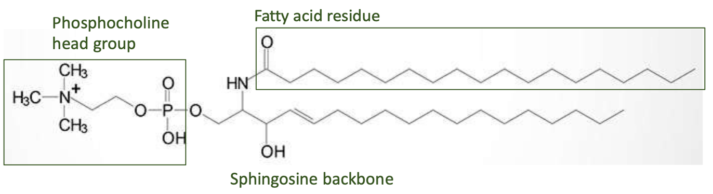

- This is a sphingolipid since it has a sphingosine backbone. The head domain is phosphocholine and lacks any sugar residues which means that this constitutes a phospholipid.
- It has a sphingosine and not glycerol backbone, which means that it is a sphingolipid.
- One fully saturated fatty acid chain of 19 carbon atoms. Fatty acid is connected to the scaffold via an amide bond, which is similar to the peptide bond in proteins.

Question 8:
A mixture composed of the lipids below is placed on a silica column and eluted with increasingly polar solvents. They will be released from the column based on the relative hydrophobicity (the most hydrophobic lipid elutes first and the least hydrophobic last).
The mix is constituted by:
- Palmitic acid,
- Cholesterol-palmitate,
- Cholesterol,
- Phosphatidylcholine
- Triglyceride.
(Please look up the chemical structures of these molecules online or in lecture slides)
In which order are these lipids eluted from the column (explain the rationale)?

Answers:
The order of hydrophobicity is:
- Cholesterol-palmitate
- Triglyceride
- Cholesterol
- Phosphatidylcholine
- Palmitic acid

Note that the ratio of hydrophobic-to-hydrophilic groups in each molecule is more important than the absolute size of the hydrophobic group. For example, cholesterol and phosphatidylcholine have comparable sizes of hydrophobic groups, but cholesterol elutes before phosphatidylcholine because of the smaller hydrophilic group (hydroxyl group versus glycero-phospho-cholate).

Red boxes indicate the hydrophobic moieties
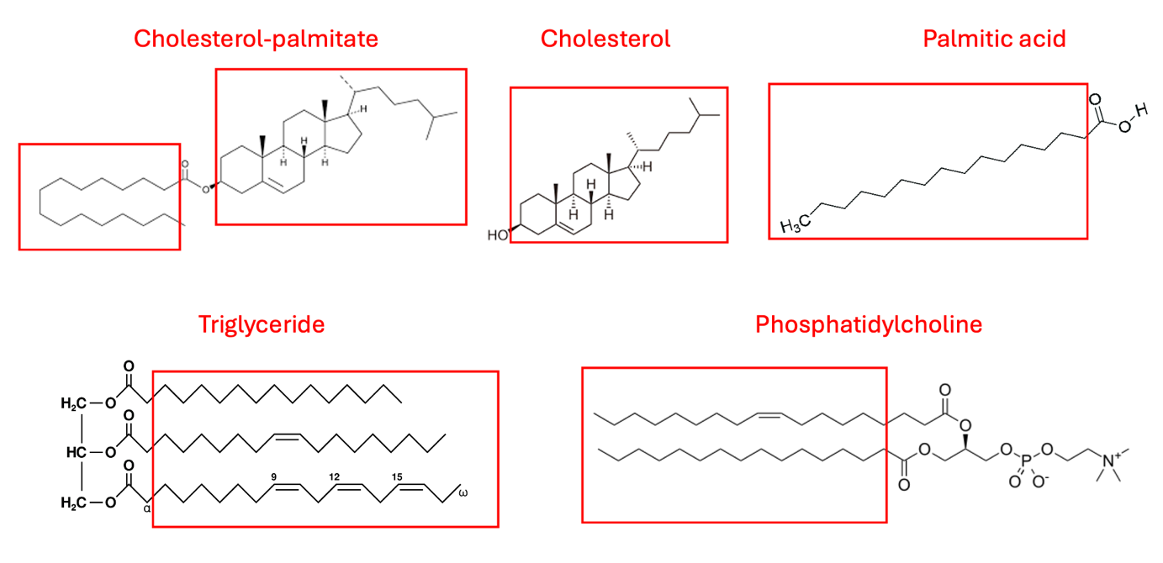
Question 9:
Some archaea that live in extreme environmental conditions such as high temperature, low pH and high ionic strength have membrane lipids containing long-chain (32 carbon atoms) branched hydrocarbons (i.e., phytanol group) linked at both ends to glycerol.
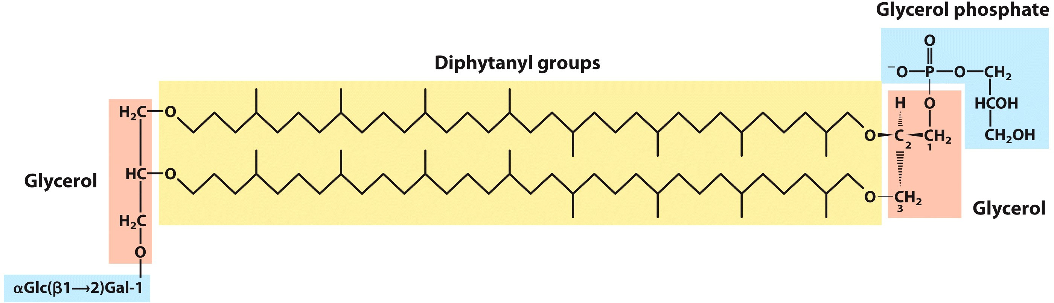
These lipids are approximately 2 times longer compared to “normal” glycerophospholipids which allows them to span through the entire membrane bilayer.

- How are these lipids helping archaea adjust to the harsh environmental conditions in terms of resistance to thermal, mechanical and chemical stresses?
- What would be the consequences of having the membrane completely composed of diphytanyl lipids? How would it affect membrane permeability?

Answers:
- These lipids serve as molecular anchors that confer greater stability to the membrane reflected in higher melting point, lower permeability and greater rigidity. These properties allow archea to survive high temperatures, mechanical stresses (e.g., boiling water, osmotic shock) and chemical stresses (e.g., low pH, high ionic strength). Of course, many intracellular components, such as proteins, need to also be able to withstand some of these harsh conditions.
- The membrane would become very rigid and impermeable to most molecules, which would affect the proliferation (e.g., cell division), motility, and chemical exchange/equilibium for the resulting organisms, making it problematic to survive. Therefore, a balanced combination of lipids is needed to assure optimal resilience and growth properties under different environmental conditions.

